**Asset Summary**

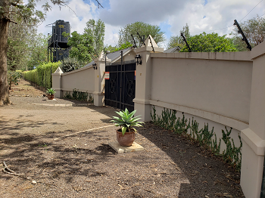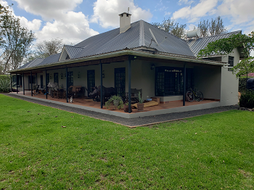

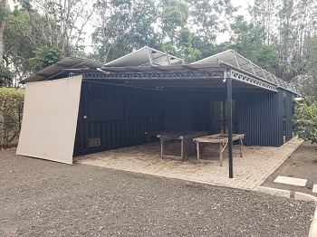 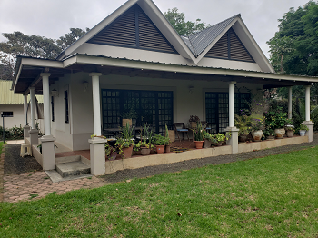

**CLIENT:**

**STODICA LIMITED**

* Level and number of services provided
* Accessibility
* Plot size
* Planning and zoning regulations

1.5 **ENVIRONMENTAL AND POLLUTION ISSUES TO THE PROPERTY**

The property is legally designated, planned and allocated use, which is proved not a threat to the environment. The locality where the property located seen to be environmentally friendly. Wastes and other related residues are properly handled with periodic collection from municipal services to the main city dumpsites. The environmental issues may be provided as hereunder:

|  |  |  |  |
| --- | --- | --- | --- |
| **S/N** | **ISSUE** | **DETAILS** | **REMARKS** |
| 1 | Waste Disposal | Household and other wastes are carefully handled and collected to the dumpsites. | No distress from waste disposal |
| 2 | Sewage and fluids | Channelling of sewage is to onsite treatment within the property and nearby properties. No evidence of discharges in the vicinity. | The surface environment is friendly |
| 3 | Waste Collection | Plastic/Paper/glass/metal is taken to a recycle facility. Garden waste is composted/burnt. Food waste is composted. General waste collected by Municipal Sanitation | Favourable collection schedules and handling |
| 4 | Noise | There are only bird noise and that may affect property users. | the property flourish in quite enjoyment and contentment |
| 5 | Neighbourhood activities | The area is residential and commercial activities which are complementing to neighbourhoods uses and scenic. | The area and property are not affected by externalities. Thus, good neighbourhood |
| 6 | Other (Restricted uses, mangroves and reserves) | There is no reserved fauna and flora which may affect use of the property | Uses in the area are at convenient of the dwellers. |
| 7 | Environmental Notices | Neither the property nor neighbourhood are provided with environmental alerting Notices. | The property proves to be Environmentally acceptable and good. |

**i) General Description**

The plot is on flat land. The plot is surrounded by mixed type properties includes colleges, Institutions, Commercial and residential properties. The plot comprises of Main building, seven (7) Rental houses with top mezzanine, one cottage house, Staff & water tank house, workshop & laundry, Generator shed, Security/ Inverter house, Coffee house, Toilet and kitchen near coffee house, Transformer/Luku house near coffee house, 7 Nos. Rental houses storeroom and car parking sheds. The pace of development on the neighbourhood is very high as the property is near the main road that is easily accessed.

**ii) PLOT AND SITE WORKS**

The property is fenced with electric fence throughout the property covering an estimated length of 669 meters surrounded with hedge fence. Entrance is via Three main gates at the front of the building, at side (Rental houses gate) and at coffee shed gate. Driveways and footpaths within the compound are surfaced with concrete slabs and gravels road respectively. The compound has a kept well lawns and gardens, flowerpots/beds and mature shade trees, Coffee trees at 100% growth and Timber trees.

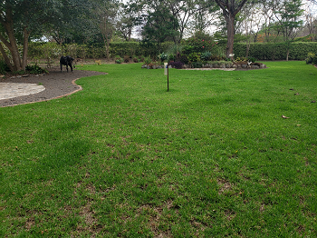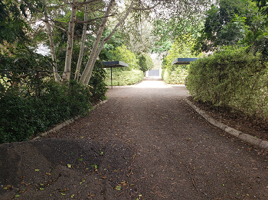

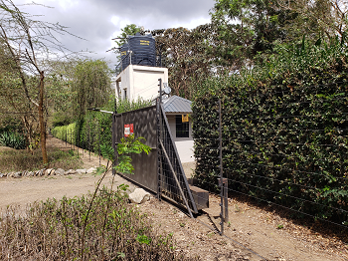

Main House Gate Main Rental access gate

iii) **SERVICES**

The property is connected with Fire extinguishers, CCTV Cameras, water and electricity from the mains, drainage is through soak away pit. Electricity supply is from public mains and supplemented with backup generator, inverter power system and elevated water storage tanks are available on metal pole tower.

**iv) Location and Locality:**

The property is located along 12/14 Katambuga road, specifically stands on **plot No. 27 & 27B part of farm no. 181/3/2 Endurance Area, Olmoti ward Arusha City**. Via Arusha bypass road from Dodoma Road the property is about 200 meters left hand side and few meters from Kivulini Hospital. The neighborhoods to the property are surrounded by mixture of Institutional, residential and commercial properties.

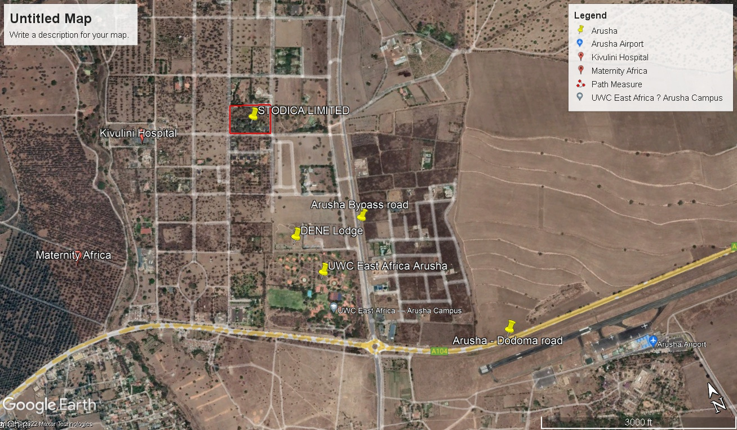***View of the neighborhood to the subject property Centered at* -3.352734 E  *36.613115 S***

**v) Tenure and Ownership:**

The subject property on **plot No. 27A & 27B part of farm no. 181/3/2 Endurance Area in Arusha District** is registered under the ownership of **The STODICA LIMITED of P. O Box 6101** for a long term of 99 Certificate of occupancy with effect from 23rd day of December 2009. Hence the term of right of occupancy enjoys 86 years of unexpired period. It is held via C.T No. 27906. The Plot covers an Area of 6.7016 Acres equivalent to 27,120.41 Square meters.

## vi) GENERAL DESCRIPTION AND DETAILS OF CONSTRUCTION

1. **MAIN BUILDING 01**

This is the single storey building built to a very good standards of workmanship and materials specification.

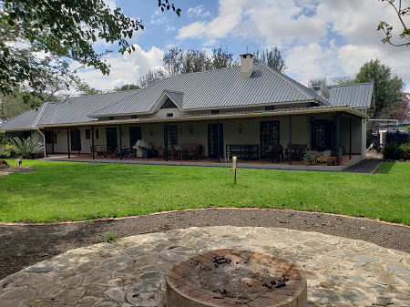

***Fire Pit in front of the main house***

**Details of Construction**

This is a single storeys residential building with pitched roof type covered with galvanized corrugated iron sheet on metal members incorporating painted timber fascia boards in closed eaves, water rain gutters and drainpipes. The veranda roof is supported by reinforced steel concrete columns and beams to the frontage side. Ceiling is of painted hardboard. Walls are of cement sand blocks plastered and painted both sides (internally and externally). Wall to the front verandah is cladded with Tanga stone tiles. Windows are of glazed casements on metal frame. Doors are of double leaf glass panels on Steel frame to entrance doors and wooden panels on timber frame internally. The floor finish is of tiles and press wood tiles. The structure accommodates inbuilt Veranda at front part and sides of the building.

**Accommodation**

The building provides for the following accommodation details:

* Sitting cum dining room
* Kitchen wing fitted with cabinets top working finish is of marble and double stainless drainer sinks.
* 1 No. of self-contained bedroom provided with wardrobe and toilet/ bathroom fitted with western type water closet, overhead shower and hand wash basin
* 2 ordinary bedrooms
* 2Nos. of public toilet/Bathroom fitted with western type water closet and hand wash basin.
* Storeroom
* Dhobi room
* Corridor
* Veranda

**Condition**

The building is in a very good state of repair and maintenance.

1. **SEVEN (7) SINGLE STOREYS WITH MEZZANINE RENTAL HOUSES**

These are double storey building built to a good standard of workmanship, design and materials specifications. The buildings are specifically used for rental house

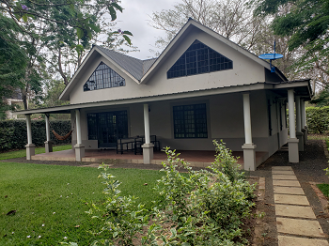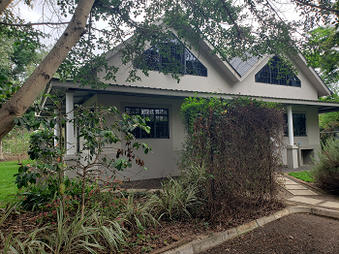

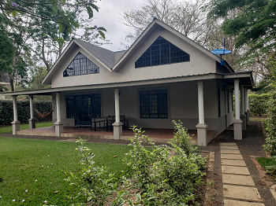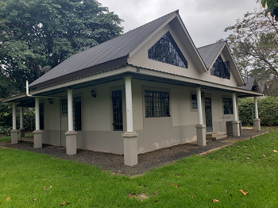

***General View of Rental house***

**Details of Construction**

They are made of similar design, details of construction, layout and material finishes arranged in rows within the compound. The roof of all structures is of galvanized corrugated iron sheet on metal members incorporating painted timber fascia boards in closed eaves, water rain gutters and drainpipes. The veranda roof is supported by reinforced concrete columns and beams to the frontage side. The ceiling is of painted hardboard. Walls are of Steel frame constructed with ferrocement outside, insulation batts internally and gypsum boards inside painted both sides (internally and externally). Windows are of glazed casements on metal frame. Doors are of double leaf glass panels on metal frame to entrance doors and wooden panels on timber frame internally. The floor finish is Slate tile in living areas, tiles in bathrooms, cement screed in downstairs bedrooms, teak wood flooring on the mezzanine. The structure accommodates an inbuilt Veranda at front part and sides of the building.

**Accommodation**

Each rental house comprises of the following accommodation.

**Ground Floor**

* Front, rear, and side Veranda.
* Spacious Sitting room
* 2 Nos. Ordinary Bedrooms
* Master bedrooms en-suited with toilet/Bathrooms fitted with western type WC, bathtub, inbuilt wardrobes, hand wash basin and wall mirrors.
* Kitchen wing fitted with cupboards topped with marble tiles, 2 hand wash basin in one water tap
* Storeroom and Laundry room
* 1No. Common toilet fitted with Western type W.C, water heater, Hand wash basin, fully height ceramic tiles.

**Mezzanine floor**

* Spacious Sitting room/Rest room
* Ordinary Bedrooms

**Condition**

The building is in a very good state of repair and maintenance.

1. **COTTAGE**

This is the single storey building built to a very good standards of workmanship and materials specification.

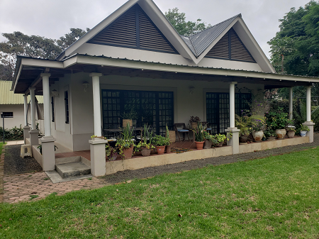

***General View of rental house 09***

**Details of Construction**

This is a single storeys residential building with pitched roof type covered with galvanized corrugated iron sheet on metal members incorporating painted timber fascia boards in closed eaves. The veranda roof is supported by reinforced steel columns and beams to the frontage side. The ceiling is of painted hardboard. Walls are of cement sand blocks plastered and painted on both sides (internally and externally). Windows are of glazed casements on steel frames. Doors are of double leaf glass panels on metal frame to entrance doors and wooden panels on timber frame internally. The floor finish is of cement sand screed and tiles to wet areas. The structure accommodates an inbuilt Veranda at front part and sides of the building.

**Accommodation**

The building provides for the following accommodation details:

* Spacious sitting cum dining room
* Kitchen fitted with reinforced concrete cabinets top working finish is of marble, single stainless drainer sinks and overhung wooden cabinets.
* 1 No. of self-contained bedroom provided with wardrobe and toilet fitted with western type water closet, overhead shower, and hand wash basin.
* Corridor
* Front, side, and rear Veranda.

**Condition**

The building is in a good state of repair and maintenance.

1. **WORKSHOP AND LAUNDRY BUILDING**

This is the a single storey workshop building built to a good standard of workmanship, design and materials specifications.

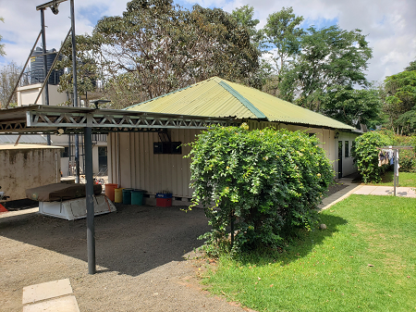

***Views of the Workshop and laundry***

**Details of Construction**

The building has a multi pitched type of roof covered with industrial trough sheets on metal members. Fascia board is provided along the eaves. The ceiling is of gypsum bords. Walls are built of Steel frame, insulation batts, gypsum boards in laundry. Workshop is steel containers. Walls to the wet areas are fitted partly with ceramic tiles.

Windows are of wooden fitted with steel bars and mosquito gauze. Doors are wooden panels fitted on wooden frames. The floor finish is of sand cement screed.

**Accommodation**

The building provides for the following accommodation details:

* Front car parking shade
* Laundry room
* 2 Nos. 20 Feet containers used as workshop stores.
* Workshop area

**Condition**

The building is in a good state of repair and maintenance.

1. **COFFEE HOUSE**

This is the a single storey coffee house built to a good standard of workmanship, design and materials specifications.

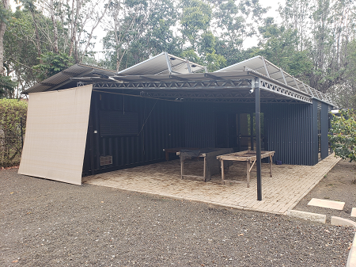

***Views of the Coffee house***

**Details of Construction**

The building has a step mono pitched type of roof covered with industrial trough sheets on metal members. Walls are built of galvanized sheet on metal poles and 40 Feet steel container. Doors are of glass poles on metal frame. Windows are of metal shutters on metal frame. Floor finish is of interlocking blocks (pavements).

Windows are of steel frame and glass fitted with steel bars and mosquito gauze. Doors are steel doors on steel frame. The floor finish is of sand cement screed.

**Accommodation**

The building provides for the following accommodation details:

* Front Veranda
* Production area
* Store area and Office room

**Condition**

The building is in a good state of repair and maintenance

1. **STAFF HOUSE AND WATER TOWER BUILDING**

This is the a double storey staff and water tower built to a good standard of workmanship, design and materials specifications.

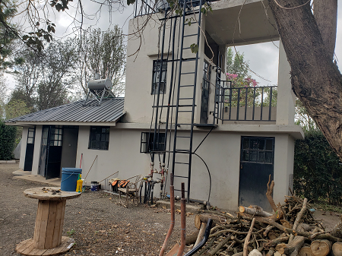

***Views of the Staff house and water tower***

**Details of Construction**

The building has multi pitched and mono pitched type of roof covered with industrial trough sheets on metal members and concrete slab to water tower. Walls are built of columns and beams infilled with cement sand blocks plastered, rendered and painted both sides. Doors are of glass poles on metal frame. Windows are of metal casement on glass panels on metal frame. The floor finish is of ceramic tiles and sand cement screed.

**Accommodation**

The building provides for the following accommodation details:

Ground floor

* Front Veranda
* Staff Kitchen room
* Staff room
* Storeroom
* Public toilet fitted with eastern type WC

**Ground floor**

* Front Balcony
* Storeroom

**Condition**

The building is in a good state of repair and maintenance.

**7) SECURITY BUILDING AND INVERTERS**

This is the a single storey building built to a normal standard of workmaship, design and materials specifications.

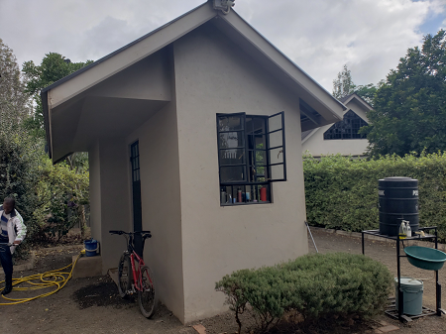

***Views of the Security Building***

**Details of Construction**

The structure is of hipped roof covered with industrial trough sheets nailed on metal purlins supported by steel members. Fascia boards is provided along the eaves. Walls are of cement sand block plastered internally, rendered externally, and painted both sides. Windows are of steel bars fitted on steel grill Doors are of double leafed steel grill and other is of steel panel fitted on steel frame. The floor finish is of sand cement screed.

**Accommodations**

The building accommodates the following accommodation details.

* Security room
* Inverter control room
* Public toilet fitted with eastern type WC and overhead shower

**Condition**

The building is in a good state of repair and maintenance.

**8) GENERATOR BUILDING**

This is the a single storey building built to a normal standard of workmaship, design and materials specifications.

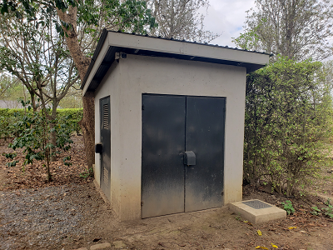

***Views of the Generator Building***

**Details of Construction**

The structure is of mono pitched type of roof covered with industrial trough sheets nailed on metal members. Walls are of cement sand block plastered internally, rendered externally, and painted both sides. Windows are of steel bars fitted on steel grill Doors are of double leafed steel grill and other is of wooden panel fitted on wooden frame. The floor finish is of sand cement screed.

**Accommodations**

The building accommodates the following accommodation details.

* Generator room

**Condition**

The building is in a good state of repair and maintenance.

**9) PUBLIC TOILET NEAR COFFEE HOUSE**

This is the a single storey building built to a good standard of workmaship, design and materials specifications.

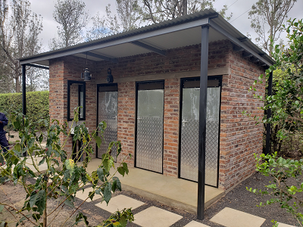

***Views of the public toilet Building***

**Details of Construction**

The structure is of mono pitched type of roof covered with industrial trough sheets nailed on metal members. Walls are of burnt bricks of fair finish externally. Windows are of steel bars fitted on steel grills. Doors are of metal shutters on metal. The floor finish is of sand cement screed.

**Accommodations**

The building accommodates the following accommodation details.

* 2 Nos. Public toilets fitted with eastern type WC and western type WC.
* Changing and washing area with basin on top

**Condition**

The building is in a good state of repair and maintenance.

**10) LOCK ROOM AND ELECTRICAL SHED**

This is the a single storey building built to a good standard of workmaship, design and materials specifications.

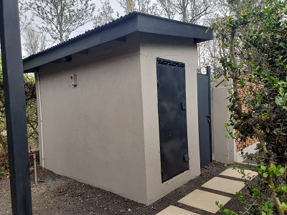

***Views of the Generator Building***

**Details of Construction**

The structure is of mono pitched type of roof covered with industrial trough sheets nailed on metal members. Walls are of cement sand blocks plastered, rendered and painted both sides Windows are of steel bars fitted on steel grills. Doors are of metal shutters on metal. The floor finish is of sand cement screed.

**Accommodations**

The building accommodates the following accommodation details.

* Lock room
* Electrical transformer shed.

**Condition**

The building is in a good state of repair and maintenance.

**11) STOREROOM AT RENTAL HOUSES**

These are single storey store rooms built to a good standard of workmaship, design and materials specifications.

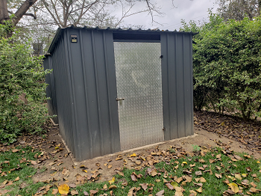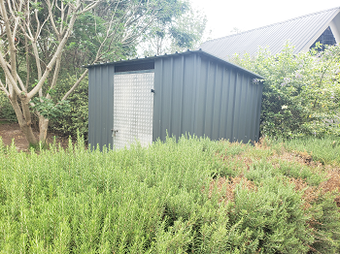

***Views of the storerooms***

**Details of Construction**

The structures comprise mono pitched type of roof covered with industrial trough sheets nailed on metal members. Walls are of galvanized iron sheet on metal poles. Doors are of metal shutters on metal frame. The floor finish is of sand cement screed.

**Accommodations**

* Each rental house comprises one storeroom house.

**Condition**

The building is in a good state of repair and maintenance.

**12) CAR PARKING SHEDS**

These are single storey store rooms built to a good standard of workmaship, design and materials specifications.

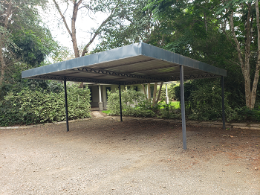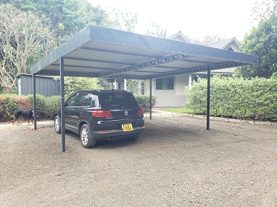

***Views of the parking shed***

**Details of Construction**

The structures comprise mono pitched type of roof covered with industrial trough sheets nailed on metal members. Walls are of metal poles.

The shades accommodate parking lot

**Condition**

The building is in a good state of repair and maintenance

Floor plan Sketches

Note: Sketches are not in Scale

